**SPOTIFY APP**

Started kafka zookeeper on AWS

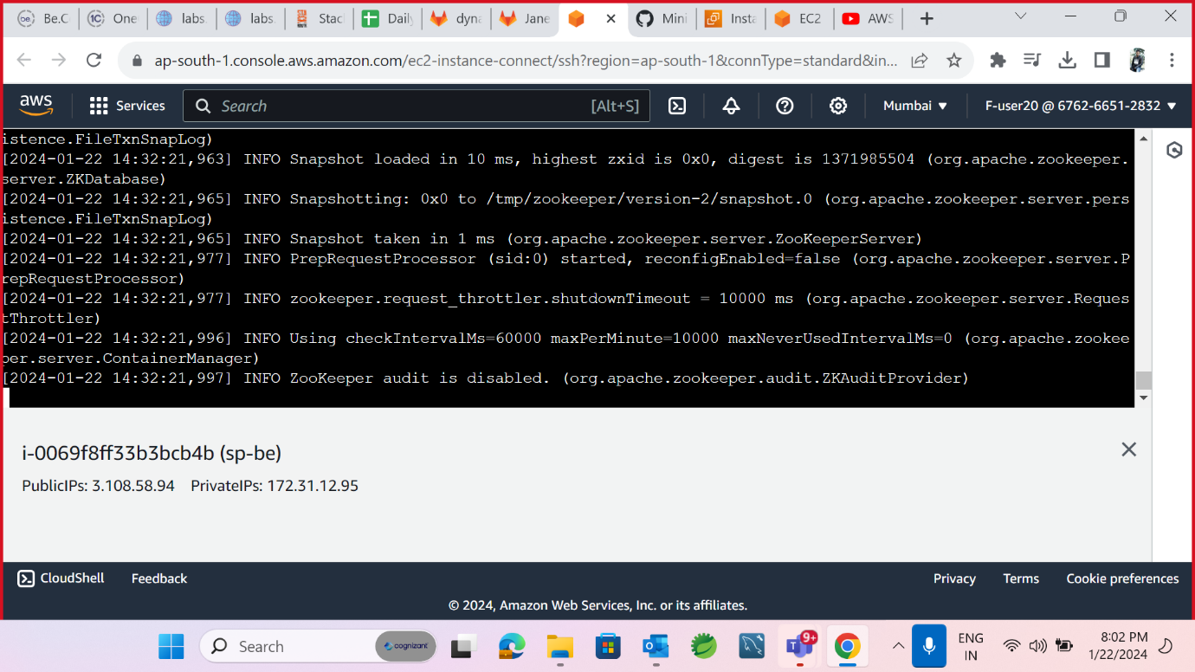

Started kafka server

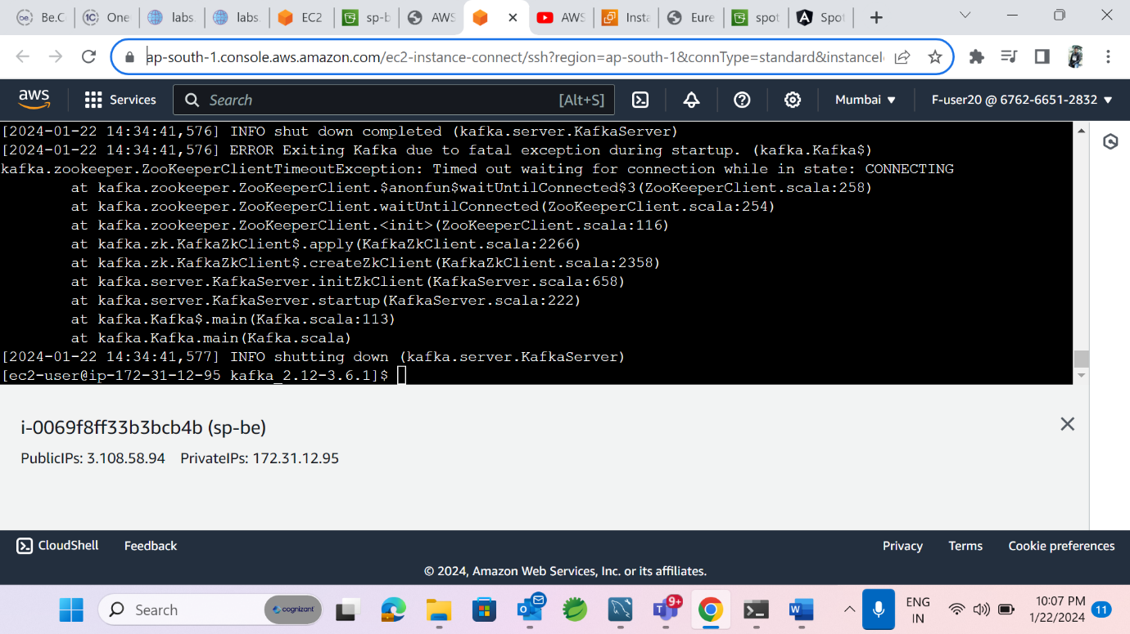

Installed Java on AWS

Created RDS

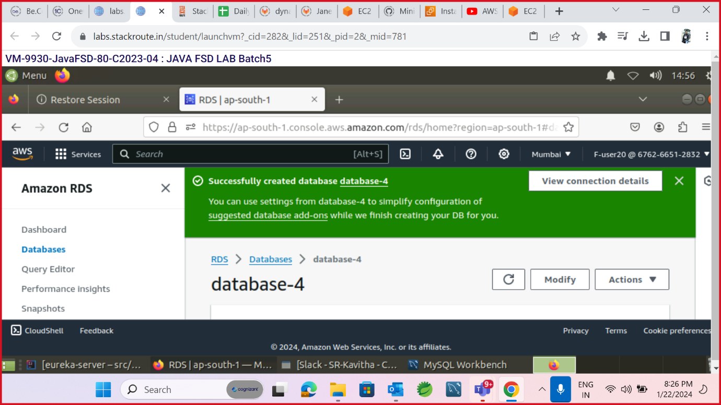

Created S3 Bucket to upload Jar

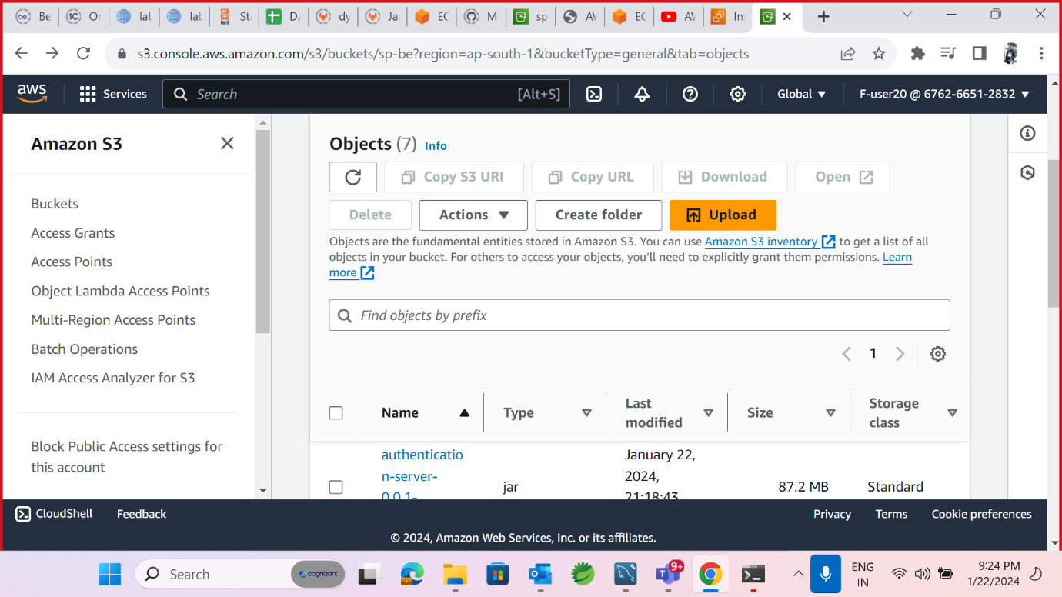

Started Eureka server

Started Config microservice

Started User Profile microservice

Started Authentication Microservice

Started Music App Microservice

Started Whistlist Microservice

Deployed S3 for Angular

